CSA 1717-ARTIFICIAL INTELLIGENCE
LAB EXPERIMENTS
Abinaya Sri J(192524429)
AIM
To solve the 8-Puzzle Problem using the A* Search Algorithm in Python.
OBJECTIVE
To find the shortest path from the initial state to the goal state. To understand the working of the A* Search Algorithm and heuristic function.
ALGORITHM
Step 1: Start.
Step 2: Define the initial state and goal state.
Step 3: Calculate the heuristic value (number of misplaced tiles).
Step 4: Find the position of the blank tile (0).
Step 5: Generate all possible moves (Up, Down, Left, Right).
Step 6: Calculate the evaluation function:
$$f(n)=g(n)+h(n)$$
where:
- g(n) = Cost from the initial state.
- h(n) = Number of misplaced tiles.
Step 7: Choose the state with the smallest f(n) value.
Step 8: Repeat until the goal state is reached.
Step 9: Print the solution path.
Step 10: Stop.
SOURCE CODE
import heapq

goal = [
[1,2,3],
[4,5,6],
[7,8,0]
]
# Heuristic Function
def heuristic(state):
count = 0
for i in range(3):
for j in range(3):
if state[i][j] != 0 and state[i][j] != goal[i][j]:
count += 1
return count
# Find Blank Space
def find_blank(state):
for i in range(3):
for j in range(3):
if state[i][j] == 0:
return i, j
# Generate Next States
def neighbors(state):
x, y = find_blank(state)
moves = [(-1,0),(1,0),(0,-1),(0,1)]
result = []
for dx, dy in moves:
nx = x + dx
ny = y + dy
if 0 <= nx < 3 and 0 <= ny < 3:
new_state = [row[:] for row in state]
new_state[x][y], new_state[nx][ny] = new_state[nx][ny], new_state[x][y]
result.append(new_state)
return result
# Convert List to Tuple
def convert(state):
return tuple(tuple(row) for row in state)
# A* Search
def astar(start):
queue = []
heapq.heappush(queue,(heuristic(start),0,start,[]))
visited = set()
while queue:
f,g,state,path = heapq.heappop(queue)
if state == goal:
print("Solution Found\n")
for step in path+[state]:
for row in step:
print(row)
print()
return
if convert(state) in visited:
continue
visited.add(convert(state))
for next_state in neighbors(state):
heapq.heappush(
queue,
(g+1+heuristic(next_state),
g+1,
next_state,
path+[state])
)
# Initial State
start = [
[1,2,3],
[4,0,6],
[7,5,8]
]
astar(start)
FLOW CHART
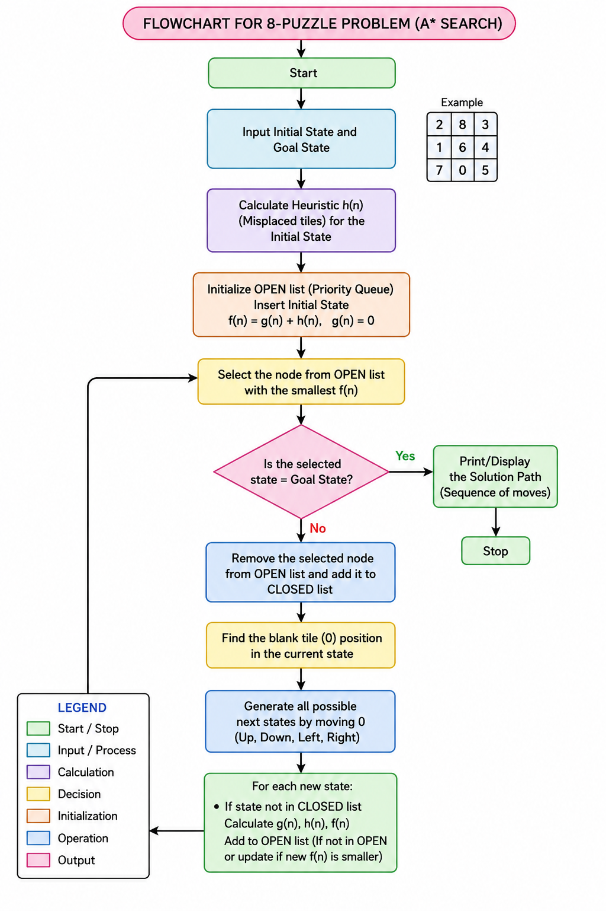
OUTPUT
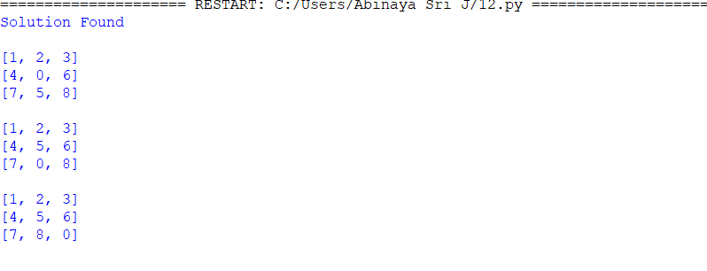

RESULT
The 8-Puzzle Problem was successfully solved using the A* Search Algorithm. The program found the shortest path from the initial state to the goal state.

